CS 340 – Project Two
Grazioso Salvare Dashboard
Student: Rafael Salazar
Date: February 22, 2026

Project Overview
This project implements a full-stack dashboard application for Grazioso Salvare using MongoDB as the database layer and Dash (Plotly) for the web interface. The dashboard allows users to filter and analyze dogs suitable for search-and-rescue training based on specific criteria such as breed, age, and sex.

Required Functionality Achieved
• Interactive rescue type filtering (Water, Mountain/Wilderness, Disaster/Tracking, Reset)
• Dynamic DataTable connected to MongoDB
• Breed distribution pie chart that updates based on filters
• Interactive geolocation map displaying selected animal location
• Integration with custom CRUD Python module from Project One

Dashboard Screenshots

Screenshot 1 – Default / Reset View
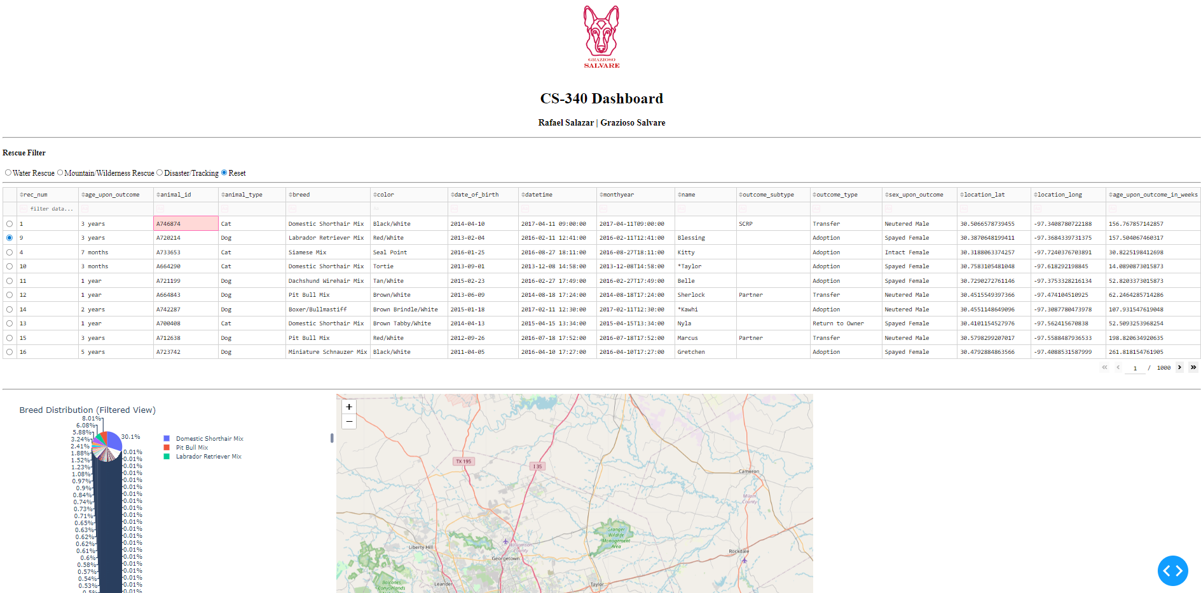

Screenshot 2 – Filtered View Example
Disaster/Tracking
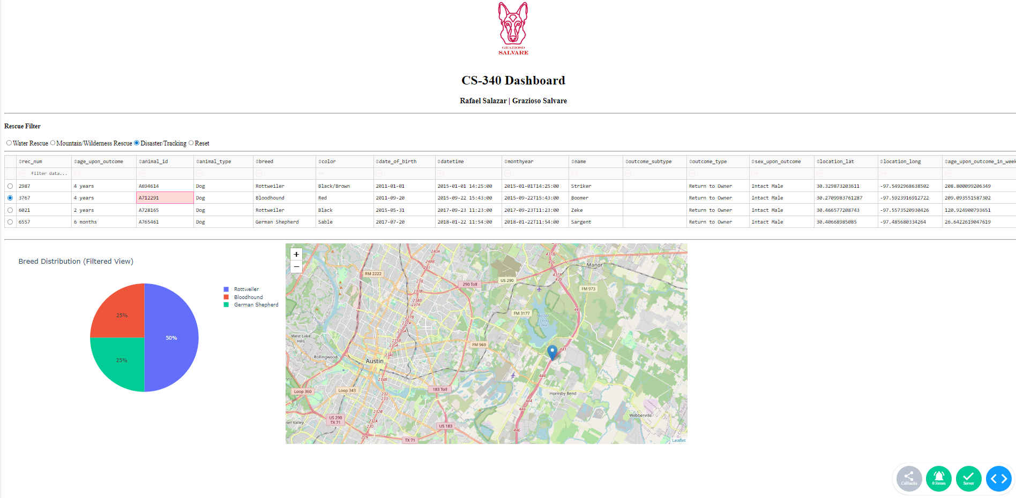
Mountain/Wilderness Rescue
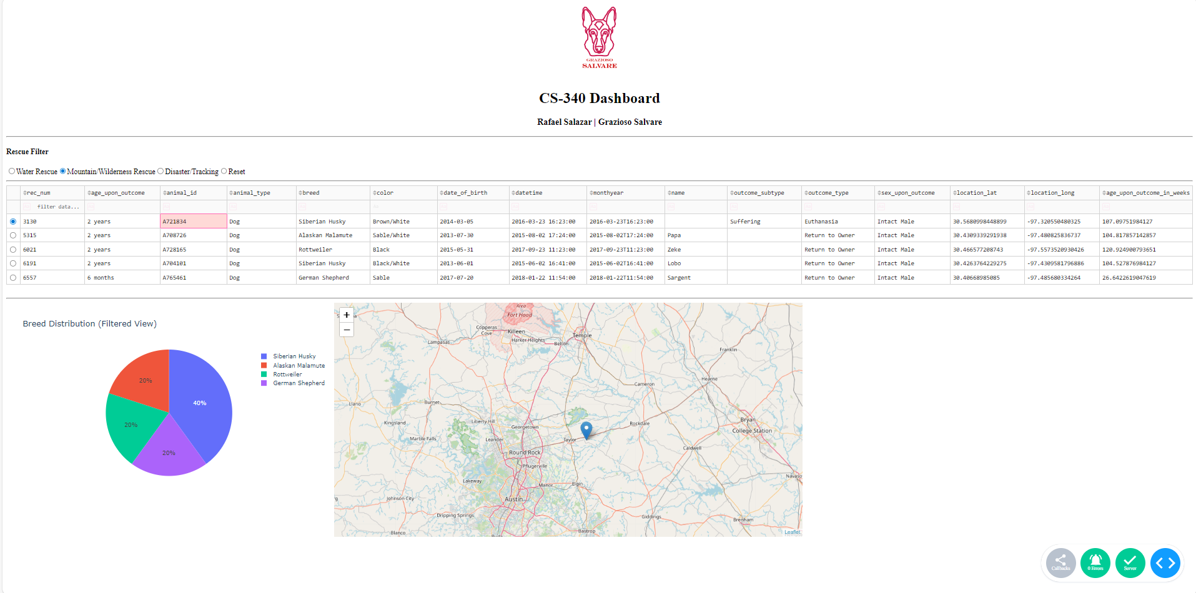
Water Rescue
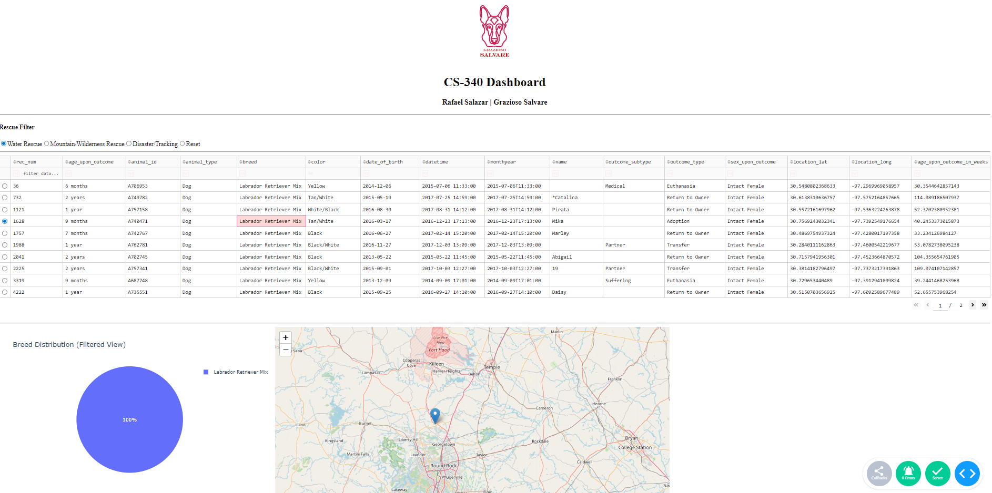

Tools and Technologies Used
MongoDB: Used as the database model component due to its flexibility, document-based structure, and seamless integration with Python via PyMongo.
Python: Used to build the CRUD module and connect the application to MongoDB.
Dash (Plotly): Used to create the interactive web-based dashboard interface.
JupyterDash: Allowed deployment and testing directly within Jupyter Notebook.

Steps Taken to Complete the Project
1. Built and tested MongoDB CRUD module (Project One).
2. Connected CRUD module to Dash dashboard.
3. Created interactive radio filters with MongoDB queries.
4. Built DataTable with sorting, filtering, and pagination.
5. Created dynamic pie chart visualization.
6. Implemented interactive geolocation map using Dash Leaflet.
7. Tested functionality and captured required screenshots.

Challenges Encountered and Solutions
• Module import errors were resolved by correcting the CRUD module import path.
• MongoDB ObjectID issues were resolved by removing the '_id' field before loading data into the DataTable.
• Map rendering issues were addressed by validating latitude and longitude column names.
• Filter logic was refined to ensure correct breed and age criteria per rescue type.

README – Instructions to Reproduce the Project
To reproduce this project:
1. Install Python 3.9+
2. Install required libraries: dash, jupyter-dash, dash-leaflet, plotly, pandas, pymongo
3. Ensure MongoDB is running locally with the 'aac' database loaded.
4. Place CRUD_Python_Module.py and ProjectTwoDashboard.ipynb in the same directory.
5. Update the MongoDB password in the notebook.
6. Run the notebook cells and execute app.run_server().

